# Handover Notes

05/06/19

Peter Yates

# Summary

This document provides an overview and broad index of Peter Yates’ work between September 2018 and May 2019. For any further information please contact Peter at [peter.yates2@my.jcu.edu.au](mailto:peter.yates2@my.jcu.edu.au). ~75% of Peter’s time was spent in R. Hence most of what he left behind is R code, especially for the 2004 OPC work. Below are directions to the index for that R code.

# 2004 OPC

* This work is located in ‘C:\Users\Peter\OneDrive - Sydney Institute of Marine Science\OPCmodelling’
  + The folder structure is hopefully self-explanatory: “data, code, plots” etc.
* To replicate the various analyses, the code needs to be run in a particular order. Hence the most important file is ‘Work Flow.txt’. This file outlines the sequence to follow.
* Peter has spent a lot of time bringing together the CTD data and 2004 OPC data. The intention is to characterise the relationships between (1) zooplankton biomass, abundance, NBSS slope and NBSS intercept and (2) environmental variables.
* ‘Proposed approach.pptx’ in folder ‘C:\Users\Peter\OneDrive - Sydney Institute of Marine Science\OPCmodelling\7stats consults and meetings’ provides a summary of Peter’s proposed approach.
  + This contains a list of the different variables and their sources.
* The challenge was that in 2004 the OPC only measured zooplankton things plus temperature, depth and salinity. I wanted some more from the CTD tows that we done after the OPC tows.
* The first step was to investigate the spatial and temporal separation of the OPC and corresponding CTD tows were sufficiently small to justify integrating them in an analyses.
  + The plots relating to this are in ‘Proposed approach.pptx’
  + See ‘Work Flow.txt’ for direction to where the code etc are located.
* If you’re wondering what Peter spent much of his time on – see ‘Peters todo list.doc’ in ‘C:\Users\Peter\OneDrive - Sydney Institute of Marine Science\Hand Over\2004 OPC’.
* There is a separate and superseded project folder at C:\Users\Peter\OneDrive - Sydney Institute of Marine Science\Data paper 1. I don’t expect anyone to need anything from here as I re-did the important stuff in the folder mentioned above. But it is there just in case!

# Microbes~zooplankton

* The email chain that prompted this work is ‘Microbe_zoop idea.pdf’ located in the ‘Hand over’ folder.
* We hadn’t really started work on this other than some initial exploration of the data that is available.
* Preliminary work by Peter are located in ‘C:\Users\Peter\OneDrive - Sydney Institute of Marine Science\Microbes Zooplankton’
* The larval fish data is from Paloma (and the Smith etal Sci Data paper). It is called ‘All data NIMO120118 v3’
* The zooplankton data comes from AODN. The various data files are located in ‘C:\Users\Peter\OneDrive - Sydney Institute of Marine Science\Microbes Zooplankton\1data’.
* There is some code for processing the NIMO data and making some preliminary MDS plots in the ‘Microbes Zooplankton’ folder.
* Here is Peter’s to do list:
  + *Work out sample size, species, spatial and temporal distribution of*
    - *Existing larval fish (James Smith Sci Data paper)*
      * *Since 2014, larval fishes have been routinely collected at five reference stations (Fig. 1), with samples sorted and larval fishes identified at the three east coast stations.*
    - *Paloma's samples ETA*
    - *NRS zooplankton (east coast) (biomass and abundance)*
      * *Just copepods? No*
      * *2012 onwards has been approximately monthly at three east coast stations.*
    - *Match with microbes (i.e. 2012 onwards)*

# MHW

* This work was discontinued due to insufficient number of NRS zooplankton samples corresponding to heatwaves (at various depths and time windows).
* The R project, code and data are located in C:\Users\Peter\OneDrive - Sydney Institute of Marine Science\Marine heatwaves\Working Directory

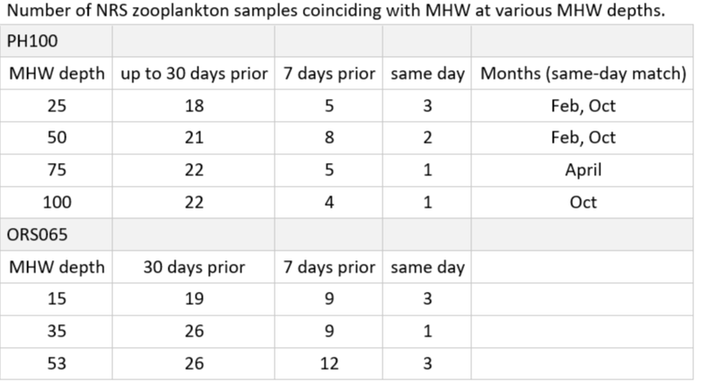

* And using MHW time-series from optimally interpolated SST - which means no gaps (as opposed to mooring data):
  + Of the 102 NRS zooplankton biomass samples between October 2009 and May 2018, 12 were on the same day as a MHW, and 22 were followed by a MHW within 14 days.

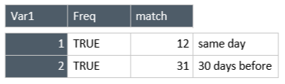

# ISW review

* This work is still at the outlining stage.
  + A large body of literature has been collected and located in the endnote folder C:\Users\Peter\OneDrive - Sydney Institute of Marine Science\ISW Review\Endnote
  + This library is also searchable by the key words listed below.
* …. Provides an index of the content, concepts and references that Peter identified as most relevant. This is assembled into an ‘outline’ style however is much too long and the concepts need refining.
* More discussions are required to resolve….
* Planned work included… (the graph etc).
* Based on a lengthy meeting with the team on 10th December, the next steps are to:
  + Make a version 2 of the outline that:
  + organises/integrates physical and ecological processes according to temporal scale (as we discussed on Monday) **AND/OR** following a similar structure to Bennett et al 2016,
  + considers ISW, in general, as where surface and bottom Ekman layers mix (e.g. Figure 1 below; Jochen Kämpf),
  + also acknowledging variability and possible exceptions to this, e.g. due to geographic differences (bathymetry, coastline, tides, fresh-water input)
  + focuses on plankton i.e. it will review and highlight the influence of ISW on phytoplankton production and zooplankton biomass, in comparison to the rest of the shelf.
  + includes a figure that (I hope!) illustrates the research gap in, and significance of, ISW.
  + for at least one specific case study e.g. the temperate eastern Australian shelf
  + Y axes = the number of observations/studies, including estuaries and intertidal studies
  + X axis = depth
  + various coloured lines for:
  + # studies on plankton/zoopl/forage fish/reef fish/sharks/benthic organisms; fishery effort; CPUE; # IMOS observations per facility etc.
* And also include:
  + build a case for a stronger identity for ISW and its ecology, primarily the plankton (similar to Bennett’s great southern reef). To this end, I have focussed on including:
    - Work by Jochen Kämpf (+7 papers and 1 book – “upwelling systems of the world”)
    - Literature search of ‘coastal boundary layer’ (+18 really good papers to my list [Nickols, Shanks, Morgan etc])
    - Tracking forward in time from Lentz and Fewings 2012, i.e. exploring ISW as it is illustrated in the figure below.
    - Topographically-constrained ‘upwelling shadows’ (Kamph, Morgan, Creswell) and their effects on productivity, retention, recruitment
    - Reviews re coupling between oceanographic research and coastal research (another useful book is on its way from Canberra)

# Fisheries modelling

* The data are not yet available for this work.
* The concept and initial communications with Matt Taylor are located in …..
* Peter has forwarded on to Iain the data sharing agreement which needs to be signed and returned to Matt to progress toward accessing the data.

# Tiger sharks

* This work was planned with Paul Butcher at DPI and Fabrice Jaine.
* Here is a summary of Peter’s initial thoughts:
  + “There are ~80 acoustic tagged tiger and ~20 SPOT tags. I’d like to make models investigating temporal and environmental drivers of occurrence and residency of tiger sharks along the coast…perhaps in latitudinal strips. Given that the tigers were tagged quite recently that this may need to be at a weekly scale to give enough rows for the models. I’d also need an offset variable to account for any changes in the number of detectable sharks and/or number of receivers per week per latitudinal strip. I have easy access to a range on environmental datasets via the AODN, and something ‘new’ I’d like to investigate is the potential effect on HF-radar-derived sea surface currents at the Coffs Harbor line (given that’s also where the radar is).”
* Please contact Paul for up to date information on the status of that work.
* A few paper etc are located in C:\Users\Peter\OneDrive - Sydney Institute of Marine Science\Sharks

# Miscellaneous

* Notes and action items coming out of all of the various meetings Peter had can be found at this link on the SIMS sharepoint: [Meetings](onenote:https://sydneymarine-my.sharepoint.com/personal/peter_yates_sims_org_au/Documents/Peter%20@%20Sydney%20Institute%20of%20Marine%20Science/Meetings.one#section-id={F1A601E1-F394-4AF6-A1C6-82C278FC9378}&end)  ([Web view](https://sydneymarine-my.sharepoint.com/personal/peter_yates_sims_org_au/_layouts/OneNote.aspx?id=%2Fpersonal%2Fpeter_yates_sims_org_au%2FDocuments%2FPeter%20%40%20Sydney%20Institute%20of%20Marine%20Science&wd=target%28Meetings.one%7CF1A601E1-F394-4AF6-A1C6-82C278FC9378%2F%29))
* Slides etc for various meetings and workshops are located in C:\Users\Peter\OneDrive - Sydney Institute of Marine Science\MeetingsWorkshops

# ISW endnote library search terms

* Zoop~eddies
* Upwelling
* Enviro change
* Climate change ~zoop
* Nearshore gradients
* Inshore water/plankt (Baird et al 2011)
* Phytoplankton
* Cold/warm plankton patterns
* Zoop~fish
* DAR
* NRS  
  gliders
* Nets
* Review
* CARS
* SS  
  entrainment
* ISW
* Intro to SS
* ISW intro
* ISW physical
* ISW biological
* ID ISW
* Food limitation
* MHW
* Artificial reef
* Wall of mouths
* Enrichment
* Residency
* HF radar
* Acoustics
* wind
* intrusion
* CBL (coastal boundary layer)
* Internal wave
* Retention
* Upwelling shadow
* Stommel